**Kol Simcha Torah Gazette**

**For parsha pekudei 5785**

Volume 9 Issue 27 (Whole #441) 29 Adar 5785/ March 29, 2025

**Printed L’illuy nishmas Nechama bas R’ Noach, a”h**

For a free subscription, please forward your request to [***keren18@juno.com***](mailto:keren18@juno.com)

***Past emails can be found on the website ShabbosStories.com under Brooklyn Torah Gazette***

**Giving Up His First-Class Seat for a WWII Veteran**

**by**[**Rabbi Shraga Freedman**](https://aish.com/authors/rabbi-shraga-freedman)



Moshe Feder simply wanted to do the right thing. Then the unexpected happened.

Moshe Feder, an observant Jewish businessman from Lakewood, NJ, was waiting for his flight at Newark Airport. Dressed in his work polo with the logo of his company, Modular Closets, and wearing a black kippah, he was preparing for a business trip when an announcement came over the loudspeaker.

“Ladies and gentlemen,” the airline employee announced, “we have the honor of having a 96-year-old former lieutenant who served in World War II on this flight. He will be seated in row 15, and I’m sure he would appreciate it if you took a moment to thank him for his service to our country.”

As Moshe listened, he glanced at his first-class ticket. He had been fortunate to receive an upgrade but now he saw an opportunity to do something meaningful. Without hesitation, he walked up to the airline representative at the gate.

“I’d like to offer my first-class seat to the veteran,” he said. “He deserves it far more than I do.”

The flight attendant was visibly moved. She picked up the microphone again and shared the gesture with the waiting passengers. “Ladies and gentlemen, I’d like to recognize this incredible act of kindness. A passenger has just offered his first-class seat to our honored veteran.”

For a moment, there was silence—then the entire waiting area erupted into applause. Strangers smiled at Moshe, nodding their approval. He felt a mix of emotions—surprise at being singled out and a deep sense of fulfillment. He had simply done what felt right, but now, with dozens of people looking at him with admiration, he realized something profound: Every action we take in public reflects our values. Small moments like this have the power to inspire others.

Before boarding, the airline representative escorted Moshe to the first-class section to personally introduce him to the veteran. The elderly man shook Moshe’s hand firmly and thanked him warmly. Moshe, now seated in economy, knew that a little extra legroom was a small price to pay for the privilege of showing gratitude to someone who had served.

The story, however, didn’t end there.

Because he had given up his first-class seat, Moshe disembarked later than he normally would have. When he finally arrived at the car rental counter, another customer noticed the company logo on his shirt.

“Hey, do you install closets in apartment buildings?” the man asked.

It turned out he was a manager at a major real estate company—one Moshe’s business had been trying to connect with for years. That “chance” meeting led to a long-term, fruitful relationship.

“The only reason I met that person was because I had been delayed those few extra minutes after giving up my seat,” Moshe said. “I truly believe that when we choose to do the right thing, good things have a way of finding us.”

As someone who often traveled for work, Moshe realized that business trips aren’t just about closing deals—they’re about how we show up in the world. If we keep our eyes open, life presents us with countless opportunities to be kind, to make a difference, and to leave a positive impression of who we are.

*Reprinted from the current website of aish.com*

**Rav Avigdor Miller on**

**Can You Lose Olam Haba**

**By Watching Television**

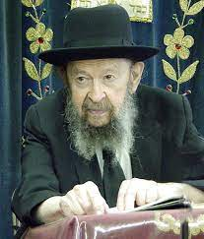

**QUESTION:** You mentioned before that a person loses their Olam Haba (share in the World to Come) by going to the movies. Do you lose it also by watching TV?

**ANSWER:** Now to make any extreme statements would be out of place here but the truth is that a man can chas veshalom (heaven forbid) lose his Olam Haba even by reading books. I don't want to say what the Gemara says about that – people who learn know. But whatever it is, we have to know that Olam Haba is a very delicate and very easily lost thing and therefore we have to guard it with the utmost care.

Now since this lady mentioned going to the movies, on this account I feel I'm standing on safe ground. The movies today are a place of extreme wickedness and it should be publicized that this is so. As many people as possible you should inform of the great peril – if the person is a Jew – of the great peril to his neshamah (holy soul) of going to movies. Even women should know when they watch movies they're actually selling themselves into Gehinom. And there's a good reason for it.

If even if , reading wicked books can make you lose your Olam Haba – it’s only books – so when you go to a place where it's pictures and they're geared only for low passions there's no question a person is going to end up by being corrupt through and through.

*Reprinted from the Parshas Vayakhel 5785 email of Toras Avigdor based on a Thursday night lecture taped in April 1975.*

**Historic Photo of Jewish Peddler in America**

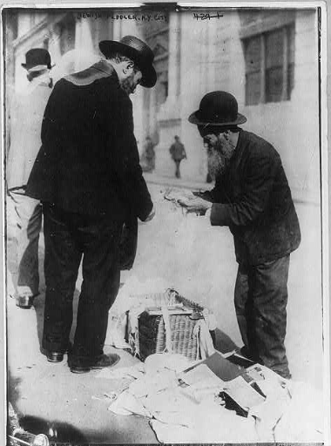

Undated photo (circa late 19th or ealy 20th Century) -of a Jewish peddler in New York City. Photo taken by Bain News Service and now part of the George Grantham Bain Collection in the Library of Congress in Washington, DC.

**The Lesson of the Tabernacle: The**

**Power of a Simple Jew to Transform**

**the World by Performing Mitzvahs**

**From the Teachings of the Lubavitcher Rebbe**

**Rabbi Menachem Mendel Schneerson, Zt”l**



This week's Torah portion, Pekudei, enumerates all the details that pertain to the erection of the Tabernacle, a subject that has already been dealt with exhaustively in the previous chapters of the Torah. If the purpose of this week's portion is to teach us that indeed, all the work on the Tabernacle was carried out exactly as G-d had commanded, would it not have sufficed to say so in one sentence? Why go through the bother of listing every single detail all over again?

This question can also be asked about another section of the Torah, which speaks about the period immediately following Moses' completion of the Tabernacle. Each of the 12 leaders of the tribes of Israel brought offerings to the newly erected Sanctuary, and the Torah tells, in great detail, what these offering entailed. Yet on the face of it, all 12 offerings were identical. Why was it necessary to repeat the same words 12 times, rather than say that all of them brought the identical offerings?

The answer lies in the explanation that only externally did the 12 offerings resemble each other; spiritually, each offering had a different content and purpose. The Torah could not have said that each of the 12 leaders brought the identical offering, for in fact, they all differed from one another.

This explanation is true for this week's Torah portion as well: The Tabernacle which G-d commanded the Jews to build was in reality a different entity from the one which Moses erected. The Torah states, "These are the accounts of the Tabernacle, the Tabernacle of the testimony." This repetition of the word "tabernacle" alludes to the two sanctuaries implied by the text--the physical and the spiritual.

The physical Tabernacle was the one which G-d instructed Moses to erect. This tabernacle was built of various physical materials--silver, gold, acacia wood, etc. The second Tabernacle is the spiritual one which each of us must build, and the various building materials are spiritual entities which we must utilize to reach our goal.

Even though the spiritual Tabernacle G-d showed Moses on Mount Sinai was doubtless on a higher spiritual plane than the one built by the Children of Israel, it was precisely in the lowly, physical one where G-d's Presence dwelled. It was only after "Moses completed his tasks" that "the cloud covered the Tent of Meeting, and the Glory of G-d filled the Sanctuary." G-d desired an actual physical location in the corporeal world to show the manifestation of His infinite nature.

It is easy to belittle the power of the individual to influence his surroundings, and make an impact on the world. How can one person make a difference and bring pleasure to His Creator, when we are so puny and insignificant? The Torah answers: it is precisely because we are in such a physical world that G-d desires our performance of mitzvot. It is up to us, we who are in this world, to imbue it with G-dliness and turn it into a true dwelling place for the One Above.

*Reprinted from the Pekudei 5752/1992 edition of L’Chaim. Adapted from the works of the Lubavitcher Rebbe.*

**Rabbi Berel Wein on**

**Parshat Ki Pekudei 5785**

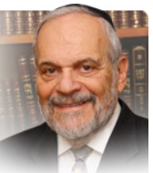

Ramban (Rabbi Moshe ben Nachman, 13th century Barcelona) points out that the conclusion of the book of Shemot, with its detailed recording of the construction and expenditures involved in the completion of the Mishkan/Tabernacle, places the Jewish people as a whole at the level of spirituality that was present in the homes of our patriarchs and matriarchs at the conclusion of the previous book of Bereshith.

Just as the spirit of the L-rd hovered over the tents of our forbearers, so now did it become recognizable and present amongst the nation of Israel. Constructed for that purpose, the spirit of the L-rd dwelled within the Mishkan/Tabernacle. There is an important message contained in this observation. This Jewish tradition teaches us that there are two places, so to speak, where the L-rd’s presence may be experienced and should be cultivated. G-d’s glory fills the entire universe; He is omnipresent. But the puny human being cannot encompass the entire universe in all of its vastness and complexity. We need a personal G-d that we can relate to somehow.

That G-d can be found, according to Jewish tradition, in two places in our small and narrow world. One place is in our home, our family and our daily lives. The second place of G-dly encounter is in the house of worship and study and Torah service. That is our substitute Mishkan/Tabernacle where the spirit of G-d hovers over those buildings and is recognizable to us only if we are attuned and sensitive enough to experience it. These two pillars of Jewish life have accompanied us on our long journey in the world – and through our history.

Both of these bastions of Jewish strength and vitality – the home and the synagogue/study hall – the meeting places so to speak of Israel with its G-d, are under siege and attack in today’s modern society. The home, marriage, children and the sense of family has given way to relationships, moving-in and out, later marriages, a large number of divorces and spousal abuse, and the sacrifice of children and family on the altars of career and hedonism.

Without strong Jewish families there cannot be a strong State of Israel or a viable Jewish nation. Certainly, intermarriage has eroded the concept of Jewish family but even when this does not occur, the bonds of family are frayed by television, the internet and the society generally. Sometimes even well-meaning gestures are counterproductive.

During my years as a rabbi in Miami Beach we always had many Shabat guests and because of that, contact between us and our own young children was pretty much eliminated. One Friday one of our younger daughters said to my wife: “Mommy, are children also guests?” We got the message and then made certain that one of the Shabat meals would be exclusively with our children.

The synagogue also has lost much since it became the matter of the whims and comfort of the attendees and no longer the House of G-d where He is to be glimpsed and served according to His wishes as expressed in Torah and halacha. I hope that the message of the Ramban will certainly not be lost upon us.

*Reprinted from the current website of rabbiwein.com*

**Thoughts that Count**

**for Our Parsha**

*These are the accounts of the Tabernacle* (Ex. 38:21)

Moses fully accounted for all the materials which went into crafting the Tabernacle. We can understand why he listed exactly how much gold, silver and gems were used; they are highly valuable. But why did he account precisely for the copper, which has so little comparative value? The copper was not a compulsory tax. The Torah recognizes that it is often those who give "freely" but less than they are truly able who demand the strictest accounting of every penny. For they are ever on the lookout for an excuse not to give any more. (Der Torah Kvall)

*The Tabernacle of the testimony* (Ex. 38:21)

The Hebrew word for testimony--"eydut"--alludes to the "adiyim" ornaments or heavenly crowns, the Jewish people received when the Torah was given. When the Children of Israel sinned by making the Golden Calf, their crowns were taken back, and with them their extra measure of spirituality. When the Tabernacle was erected, G-d forgave them their sin and their crowns were returned to them. (Ohr HaTorah)

*And Moses blessed them* (Ex. 39:43)

The fact that G-d's presence was visible when the Tabernacle was erected is not remarkable in itself, for whenever Jews gather together on Shabbat, on holidays, or to perform a mitzva as a congregation, a feeling of holiness and goodwill prevails. Moses' blessing to the Children of Israel was: "May it be G-d's will that His presence should rest on the work of your hands"--May Jews feel this closeness to G-d also during the week and while attending to their daily business concerns.

*As stones of memorial to the Children of Israel* (Ex. 39:7)

When Joseph was in Egypt and was tempted by Potifar's wife, the image of his father Jacob appeared to him, saying, "The names of all your brothers will one day be inscribed on the stones of the High Priest's breastplate. Do you want your name to be missing, if, G-d forbid, you commit this sin?" The 12 stones of the breastplate serve as a memorial for all of Israel. When a person reminds himself that all Jews were represented on it, he too will be ashamed and too embarrassed to commit any transgressions. (Meshech Chachma)

*Reprinted from the Pekudei 5752/1992 edition of L’Chaim.*

**The Dream and Downfall of the Tyrant of Jerusalem**

By [Yehudis Litvak](https://www.chabad.org/search/keyword_cdo/kid/20542/jewish/Litvak-Yehudis.htm)

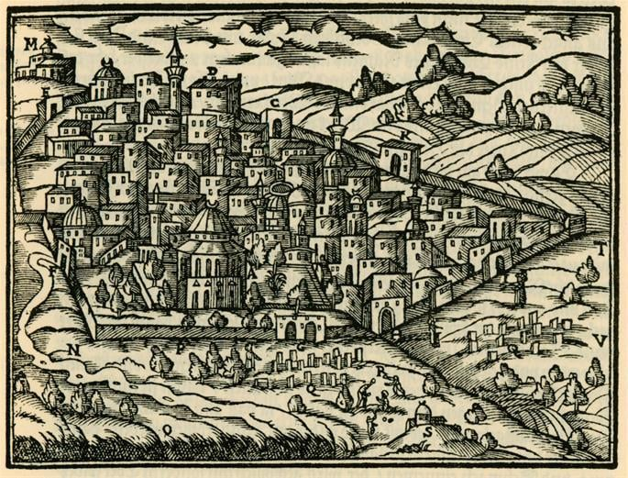

**Jerusalem by Salomon Schweigger, 1608.**

In 1627, a slim pamphlet was published in Venice. Written in flowery Hebrew, it told a story of cruelty and bravery, danger and determination. It was the story of how the Jewish community of Jerusalem was taken hostage by a cruel tyrant who imprisoned and persecuted them in an effort to enrich himself and increase his power. Apparently written to raise awareness of the people’s plight, it tells of how a mysterious dream led to his miraculous downfall.

Read on for the dramatic story of the rise and fall of Ibn Farouk.

Our story is set in early 17th-century [*Jerusalem*](https://www.chabad.org/library/article_cdo/aid/4246466/jewish/Jerusalem.htm), which was home to a vibrant and growing Jewish community numbering several hundred people. As told in the pamphlet:*[1](javascript:doFootnote('1a6819632');)*

The City of G‑d contained more of our people than at any time since the Jews were banished from their country. Many Jews came daily to live in the City, apart from those coming to pray at the Western Wall … Moreover, they brought with them bountiful gifts of money to strengthen the Jews of Jerusalem. It was reported in all countries that we were dwelling in peace and security.

Many of us bought houses and fields and rebuilt the ruins, and aged men and women sat in the streets of Jerusalem, and the thoroughfares of the City were thronged with boys and girls … The teaching of the Holy Law (the Torah) prospered, and many houses of study stood open to all who sought to engage in the labor of Heaven. The leaders of the community provided the students with their daily needs. All the poor were relieved of their wants …

Among the leaders of Jerusalem’s Jewish community at the time was [*Rabbi Isaiah Halevi Horowitz*](https://www.chabad.org/library/article_cdo/aid/112346/jewish/Rabbi-Isaiah-Halevi-Horowitz-The-Sheloh.htm), known as the Sheloh, an acronym of the title of his most famous work, Shnei Luchot Habrit. The *[Sheloh](https://www.chabad.org/multimedia/video_cdo/aid/2865197/jewish/The-Educational-Vision-of-Rabbi-Isaiah-Horowitz.htm" \o "The Educational Vision of Rabbi Isaiah Horowitz)* arrived in Jerusalem in 1621, following an illustrious career as the chief rabbi of Prague. After the death of his wife, the Sheloh fulfilled his life-long dream of settling in Jerusalem, where he was warmly welcomed and appointed the Ashkenazic chief rabbi. It was in Jerusalem that the Sheloh completed his magnum opus.

**A Tyrant Seizes Power**

At the time, the Land of Israel was part of the vast Ottoman Empire, ruled by Sultan Murad from his seat in Constantinople. The sultan, however, rarely got involved in the affairs of the provinces, and local governors enjoyed almost complete authority, as long as they maintained basic order and collected enough taxes to fill the empire’s treasury.

Jerusalem was governed by a mayor appointed by the governor of Damascus. A qadi, a Muslim judge, maintained judicial power. The sultan’s small garrison was stationed in the citadel, though its presence was largely symbolic. They rarely participated in law enforcement.

This system was reasonably fair until a corrupt and evil man, one-eyed Muhammad Ibn Faroukh, bribed the governor in Damascus and appointed himself ruler of Jerusalem.

Ibn Faroukh arrived in Jerusalem with 300 mercenaries. He deposed the rightful mayor and imposed a reign of terror on Jerusalem’s residents, seeking to enrich himself at their expense. He extorted money from Muslims, Christians, and Jews alike.

Jerusalem’s qadi objected to the injustice. He tried to speak to Ibn Faroukh to no avail. Finally, the qadi publicly condemned Ibn Faroukh’s actions. In response, the tyrant drew his sword and would have murdered the qadi had his attendant not acted quickly and saved his life.

His anger somewhat abated, Ibn Faroukh fired the qadi and replaced him with a corrupt judge who was happy to accept his bribes and overlook his wrongdoings.

With his tyranny firmly established, Ibn Faroukh took his extortion to a new level. He appointed his brother-in-law, Ibrahim Agha, as his deputy and instructed him to obtain money. Ibrahim entered Jerusalem’s marketplace with Ibn Faroukh’s soldiers and detained several of the wealthier Muslim merchants. They were released only after a large ransom was paid.

In desperation, the local Muslims attempted to flee Jerusalem, but Ibrahim locked the city gates and posted guards to ensure no one left Jerusalem without his permission. By cutting off Jerusalem’s residents from the rest of the world, Ibn Faroukh and Ibrahim made sure that no word of the corruption and tyranny would reach the sultan or the provincial governor in Damascus, allowing them to oppress the local residents without any fear of retribution.

**Ibn Faroukh and the Jews**

Ibn Faroukh and his cronies targeted the Jewish community in particular. An anonymous Jewish resident of Jerusalem recorded the events of the time in the pamphlet mentioned above. He wrote that in addition to demanding large amounts of money, Ibn Faroukh forced the Jews to dig ditches around the city walls, to prepare for a potential attack in case his evil deeds were discovered.

The reign of terror continued for two years. Ibrahim continued to demand astronomical amounts of money, which the Jewish community was not capable of paying. The community’s leaders were imprisoned and tortured. A few Jews managed to escape the city, but most were forced to go into hiding. They lived in cramped quarters and subsisted on a bare minimum of water and vegetables. Jewish institutions – synagogues, schools, soup kitchens – were forced to close. Even the [*Western Wall*](https://www.chabad.org/library/article_cdo/aid/588219/jewish/Western-Wall-Kotel.htm) became off limits to Jewish worshippers.

In the summer of 1625, Ibn Faroukh and Ibrahim set off on a pilgrimage to Mecca, leaving Ibrahim’s brother, Uthman Agha, in charge of Jerusalem.

Though Uthman demanded money from the Jewish community, the amount was much more reasonable than what was demanded by Ibn Faroukh and Ibrahim. In addition, Uthman did not issue any threats. Jerusalem’s Jews allowed themselves to hope that in Ibn Faroukh’s absence they would be safe.

Slowly, they began to come out of hiding and attend the synagogues and other communal institutions once more. Unfortunately, they fell into Uthman’s trap.

On Shabbat, a little over two weeks before Rosh Hashanah, Uthman and his soldiers stormed the synagogues while the Jews were in the middle of prayers. They arrested fifteen of the community’s leaders, including the Sheloh, Rabbi Shmuel Ibn Sid, and Rabbi Yitzchak Chavilio, demanding a large ransom for their release.

Concerned for the welfare of their beloved elderly rabbi and other leaders, the Jews of Jerusalem made a desperate attempt to collect the amount Uthman demanded. Since the communal funds and their personal savings had by then been depleted, the Jews turned to their Arab neighbors, who agreed to lend them money, but at an outrageous 50% interest rate.

Thanks to their efforts, the fifteen leaders were freed before [*Rosh Hashanah*](https://www.chabad.org/library/article_cdo/aid/4644/jewish/Rosh-Hashanah-2025.htm). But the Jewish community remained in heavy debt.

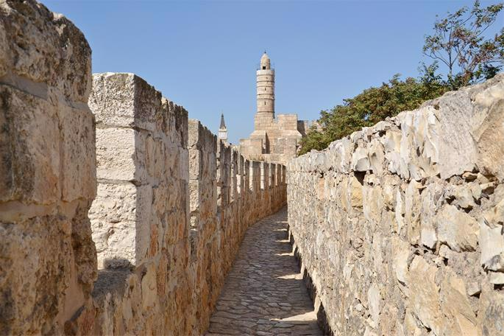

**Jerusalem's city walls and Citadel.**

**Ibn Faroukh’s Rebellion Against the Sultan**

Upon his return to Jerusalem, Ibn Faroukh took his most daring step, which proved to be his undoing. In an effort to gain even more power, Ibn Faroukh and his soldiers stormed and occupied the Citadel, driving away the sultan’s garrison. This constituted open rebellion against the sultan.

The residents of Jerusalem, and especially its Jewish population, were now completely at the mercy of the evil tyrant, who kept demanding more and more money. One of Ibn Faroukh’s henchmen attempted to arrest Rabbi Yitzchak Gaon, but the rabbi managed to escape. The henchman then arrested the Jewish doctor, Rabbi Yaakov ibn Amram, and held him hostage for ten days, until he was ransomed by the community.

The Jews of the city lived in fear, never knowing who the next victim would be. The anonymous writer reports, “We knew no peace or rest: we ate our bread in trembling and drank our water in anxiety. Even at night we could not sleep.”*[2](javascript:doFootnote('2a6819632');)*

In addition, many Jews were no longer able to feed their families. They began making escape plans.

Though escape wasn’t easy, many Jews managed to sneak out of the city. The Sheloh fled to Safed and later moved to Tiberias, where he passed away several years later, in 1630.

Some of those who managed to escape went to Damascus and reported the rebellion. The governor sent an army to Jerusalem, threatening to attack the city and depose its tyrant. At the time, Ibn Faroukh was not in Jerusalem, but Uthman had no intention of giving in. He prepared the city for the impending siege, collecting weapons, filling the moats, stopping the water cisterns, and confiscating food for safekeeping in the Citadel. Jerusalem’s residents were left without food or water and under strict military command.

Uthman increased the guards at the city gates, making sure that no one would be able to sneak out of the city. When the Jews tried to leave Jerusalem to bury their dead, the cruel guards pierced the coffin with their swords to make sure that the person was truly dead.

The anonymous contemporary Jew wrote:*[3](javascript:doFootnote('3a6819632');)*

The people were sorely afraid, for a great force had gathered at Ramleh to wage war on Uthman. All sought hiding places to conceal their wives and children. There was joy at the thought that the rule of evil was about to end; but there was anxiety lest the place be devastated by the cannon. Yet it was generally agreed that devastation and death were preferable to the City’s remaining under the rule of a wicked and heartless man.

Unfortunately, the joy was premature. After two months, the governor’s forces, seeing that Uthman was determined to withstand the attack, called off the siege and returned to Damascus.

**Uthman’s Coup**

Blinded by his success, Uthman decided that he could do better than serving as second-in-command. He plotted to assassinate Ibn Faroukh and usurp his post for himself.

When Ibn Faroukh returned to Jerusalem, he found out about Uthman’s plot. Ibn Faroukh promptly executed Uthman, and Jerusalem’s residents rejoiced to be free of their sworn enemy.

However, Ibn Faroukh himself now turned to the Jews as a means to fill his coffers. He continued to arrest and torture Jews at random, expecting the community to ransom them.

Two rabbis from Jerusalem, Rabbi Shmuel Ibn Sid and Rabbi Shmuel Tardiola, managed to leave the city and reach Constantinople in order to plead before the sultan for intervention. In Constantinople, they were joined by a qadi who became aware of the situation in Jerusalem.

Once he heard about the audacious rebellion, the sultan dispatched an army to quash it.

Meanwhile, on the last day of Sukkot, Ibn Faroukh arrested two prominent members of the Jewish community, the doctor Rabbi Yaakov ibn Amram and Rabbi Yitzchak Gaon, demanding a large ransom. On the next day, Simchat Torah, Jerusalem’s Jews were unable to rejoice, not knowing where they could possibly get the money to ransom the two hostages.

Eight days later, the Jews still hadn’t managed to obtain enough money. To exert more pressure on them, Ibn Faroukh brought the two Jewish hostages to the synagogue and tortured them in front of the community members. Even Ibn Faroukh’s army commander was so disturbed by the cruelty of the torture that he intervened with Ibn Faroukh on behalf of the two Jews.

**The Dream**

Soon afterwards, Ibn Faroukh heard that the sultan’s army was on its way to Jerusalem. A few weeks later, he had a dream in which he was being strangled by an old man. When Ibn Faroukh asked the man who he was, the old man replied, “I am King David. If you spend another night in this city, you will die!”

Faroukh woke up in terror. He loaded his camels with whatever loot they could carry and escaped Jerusalem with his henchmen, taking two Jewish hostages—hapless prisoners named Tuvyah and Yosef—with him.

When the Jews woke up, they were overjoyed to find their tormentor gone:

In the morning we thanked [*G‑d*](https://www.chabad.org/library/article_cdo/aid/433240/jewish/God.htm) in the synagogue, and we praised His name in Great Hallel for all His goodness to us in removing heathen from our land and driving away from us the wicked foe, Ibn Faroukh. Some of the sages and leaders of the Community went round the city and collected food and gifts for the poor; and there was light and joy for the Jews.

Soon, the two Jewish hostages returned, a new mayor was installed in Jerusalem, and its Jewish community began to rebuild after two years of tyranny.

**The Aftermath**

Finally free from their cruel oppressor, the Jewish community was left with large debts at steep interest rates. Much of the debt was owed to Jerusalem’s Arab residents who were now waiting to be repaid. The anonymous writer reports, “Today, we are mortgaged – men, women, and children – to the Ishmaelite dwellers of this land.”

The Jews of Jerusalem sent messengers to communities throughout Europe, requesting their help. The anonymous account of the events was likely written in order to explain to their European brethren why the need was so great. The Sheloh also wrote letters to his native Prague and to other European communities, asking for their support.

European Jews tried to help as much as they could, but ultimately, it took years for Jerusalem’s Jewish community to restore the peace and contentment they had enjoyed before Ibn Faroukh’s reign of terror.

**Footnotes**

*[1.](https://www.chabad.org/library/article_cdo/aid/6819632/jewish/The-Dream-and-Downfall-of-the-Tyrant-of-Jerusalem.htm" \l "footnoteRef1a6819632)* Churvot Yerushalayim, adapted from the translation found in Ottoman Conquest 1517-1699 (Center for Online Judaic Studies).

*[2.](https://www.chabad.org/library/article_cdo/aid/6819632/jewish/The-Dream-and-Downfall-of-the-Tyrant-of-Jerusalem.htm" \l "footnoteRef2a6819632)* Avraham Yaari. The Goodly Heritage: Memoirs Describing the Life of the Jewish Community of Eretz Yisrael from the Seventeenth to the Twentieth Centuries.

*[3.](https://www.chabad.org/library/article_cdo/aid/6819632/jewish/The-Dream-and-Downfall-of-the-Tyrant-of-Jerusalem.htm" \l "footnoteRef3a6819632)* Avraham Yaari. The Goodly Heritage: Memoirs Describing the Life of the Jewish Community of Eretz Yisrael from the Seventeenth to the Twentieth Centuries.

*Reprinted from the current website of Chabad.org*

**The Dwelling of the Testimony” (38:21).**

Why is the Mishkan referred to as the “Dwelling of the Testimony”? In the pesukim that follow, the Torah gives us an accounting of the vast amounts of gold, silver and other materials that were used in the construction of the Mishkan. It records how much was donated toward the Mishkan’s construction and how much was put to use. The Mishkan itself was the best evidence that there was absolutely no dishonesty in relation to the Mishkan’s construction, and that every last donation was accounted for and put to use. It is inconceivable that the shechinah would ever dwell in a place that was tainted with corruption. If any of the donations had been misappropriated, the shechinah would never have rested there. (HaGaon HaMalbim) (Excerpted from the ArtScroll book – “A Shabbos Vort” by Rabbi Yisroel Bronstein)

*Reprinted from this week’s email of The Weekly Vort.*